A report

submitted in partial fulfillment of the requirements of

**February-June 2023 Semester CS671:**

**Deep Learning and Applications Programming Assignment I**

**Submitted by:**

**GROUP - 9**

**SHUBHAM PATWAR (T22108)**

**SYED RIZWAN ALI QUADRI (T22113)**

**SHASHANK KAPOOR (S22022)**



**ABSTRACT OF THE PROJECT:**

This project uses Perceptron models with gradient descent for two classification tasks and two regression tasks. For classification, we used the sigmoidal activation function and one-against-one approach for 3-class classification. The main objective of this project is to evaluate the performance of perceptron on different types of datasets and to compare the classification accuracy achieved on linearly separable and non-linearly separable datasets. We found that the perceptron performs well on linearly separable datasets but struggles with non-linearly separable datasets. For regression, we used the linear activation function and MSE as the evaluation metric. Overall, our findings suggest that the perceptron algorithm can be used for regression tasks, but its performance is limited on more complex datasets. The one-against-one approach and gradient descent method have proven to be effective in improving the accuracy of the perceptron algorithm for multi-class classification. The gradient descent method is an effective way to train the perceptron algorithm, and finding the optimal learning rate is crucial for achieving good accuracy.

**GIVEN DATA FOR THE PROJECT:**

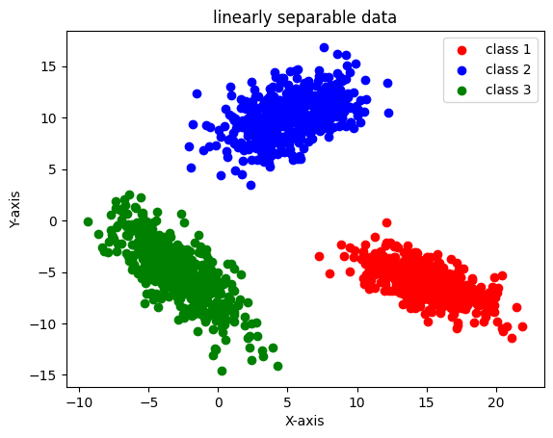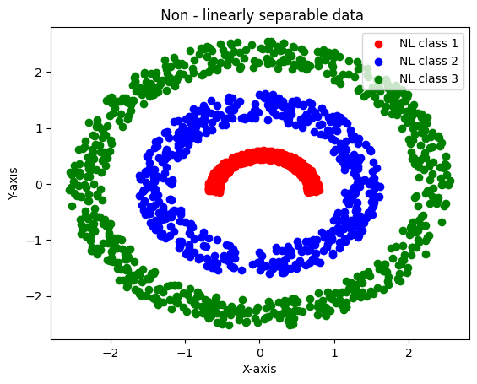This project involves two classification tasks and two regression tasks using Perceptron models with gradient descent method for learning algorithms. The first classification task involves two datasets: Dataset 1 contains linearly separable 2D data with 3 classes, each with 500 data points; Dataset 2 contains 2D nonlinearly separable data with 3 classes. The data is divided into 70% training and 30% testing for each class. For Dataset 1(linearly separable classes), a Perceptron model with sigmoidal activation function and one-against-one approach for 3-class classification is used. For Dataset 2(Non-linearly separable classes), the same Perceptron model is applied. The second classification task involves the same datasets and model, but with different data pre-processing. The regression tasks involve two datasets: Dataset 1 contains 1D univariate input data, and Dataset 2 contains 2D bivariate input data. The data is also divided into 70% training and 30% testing for each dataset. For both datasets, a Perceptron model with linear activation function and gradient descent method for learning algorithm is used. The aim is to predict the output values based on the input data. The project provides an opportunity to compare the performance of Perceptron models with different activation functions for classification tasks and regression tasks.

me datasets and model, but with different data pre-processing.

The regression tasks involve two datasets: Dataset 1 contains 1D univariate input data, and Dataset 2 contains 2D bivariate input data. The data is also divided into 70% training and 30% testing for each dataset. For both datasets, a Perceptron model with linear activation function and gradient descent method for learning algorithm is used. The aim is to predict the output values based on the input data. The project provides an opportunity to compare the performance of Perceptron models with different activation functions for classification tasks and regression tasks.